Kafka documentation:

**Step1)Download latest version from below url**

<https://kafka.apache.org/downloads>

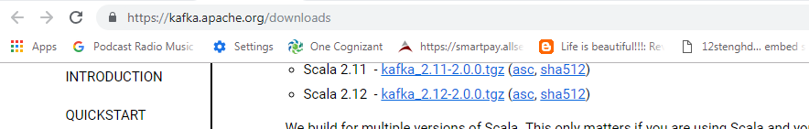

**Installation :**

**Zookeeper configuration:**

**Note:**  zookeeper by default port number is 2181

Step1) extract the downloaded kafka.tz and edit the zookeeper settings under config folder

D:\softwares\tools\kafka_2.11-2.0.0\config\zookeeper.propertes and edit log path and port number as required

dataDir=D:/softwares/tools/kafka_2.11-2.0.0/zooker-logs

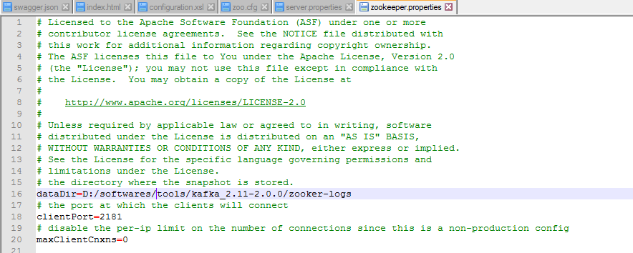

How to start zookeeper after setting zookeeper.properties?

**1)open command prompt with below path**

D:\softwares\tools\kafka_2.11-2.0.0\bin\windows>

2)execute below command

zookeeper-server-start.bat ../../config/zookeeper.properties

**final start command will look like below:**



**Kafka installation:**

**Note:**  Kafka by default port number is 9092

Step1)Open D:\softwares\tools\kafka_2.11-2.0.0\config and edit **server.properties** file with log directory and also you can edit zookeeper connection details in this file if needed.

By default zookeeper connection configuration will be **zookeeper.connect=localhost:2181**

log.dirs=D:/softwares/tools/kafka_2.11-2.0.0/logs



Step2) then start kafka using below command

D:\softwares\tools\kafka_2.11-2.0.0\bin\windows>**kafka-server-start.bat ../../con**

**fig/server.properties**

**how to create topic using command line interface?**

Execute below command:

D:\softwares\tools\kafka_2.11-2.0.0\bin\windows>**kafka-topics.bat --create --zookeeper localhost:2181 --replication-factor 1 --partitions 1 --topic test-topic**

**How to send message to topic?**

D:\softwares\tools\kafka_2.11-2.0.0\bin\windows**> kafka-console-producer.bat --broker-list localhost:9092 --topic test-topic**

Hello sreenutech

**How to consume message from above topic?**

D:\softwares\tools\kafka_2.11-2.0.0\bin\windows>**kafka-console-consumer.bat --bootstrap-server localhost:9092 --topic test-topic --from-beginning**



================finish================================================================